STUDENT PERFORMANCE ANALYTICAL REPORT

1. Introduction

Purpose and Scope
This report analyzes key factors influencing student academic performance using Grade Point Average (GPA) as the primary indicator. The analysis focuses on absenteeism, tutoring support, parental education level, and selected demographic variables.

Background
Student academic performance is shaped by a combination of behavioral, academic, and socio-economic factors. Understanding these relationships enables educational institutions to design targeted interventions to improve outcomes.

Importance of Study
Identifying the most significant predictors of poor academic performance allows schools to:
- Intervene early with at-risk students
- Improve overall academic outcomes
- Allocate resources effectively

2. Objectives

Main Objective
To determine the key factors that significantly influence student GPA.

Specific Objectives
- Examine the relationship between absences and GPA
- Identify the absence threshold where performance declines significantly
- Evaluate the impact of tutoring on student performance
- Assess the influence of parental education level on GPA
- Identify patterns among low-performing students

3. Data Source

Dataset Description
The dataset contains 2,392 student records, including:
- GPA (numeric)
- Absences (numeric)
- Tutoring status (categorical)
- Parental education level (categorical)
- Study time (numeric)
- Age and ethnicity (categorical)

Data Structure
- Numerical variables: GPA, absences, study time
- Categorical variables: tutoring, parental education, ethnicity, age group

4. Data Cleaning and Preparation

Cleaning Process
• Checked for missing or inconsistent values.
• Ensured GPA was formatted as a numeric variable.
• Grouped absences into ranges (0–4, 5–9, etc.) for better analysis.
• Using demographic details provided, the numeric codes were replaced to descriptive categories.

Transformations
- Grouped absences into ranges (0–4, 5–9, 10–14, etc.) to observe trends
- Created categories for performance levels (e.g., low, average, high performers)
- Used pivot tables to summarize GPA across variables.

5. Methodology
The analysis was conducted using descriptive statistical techniques:
- Pivot tables were used to calculate average GPA and student counts across categories
- Comparative analysis was applied to evaluate differences between groups (e.g., tutoring vs no tutoring)
- Trend analysis was used to observe how GPA changes with increasing absences
GPA was selected as the primary metric because it provides a standardized measure of academic performance.

6. Data Analysis and Findings

6.1 Absenteeism and Academic Performance
A strong negative relationship exists between absences and GPA.
- Students with 0–4 absences recorded the highest average GPA (~3.2)
- Students with 25–29 absences recorded the lowest GPA (~0.7)
- A sharp decline in performance occurs after approximately 15 absences
Insight: Students exceeding 15 absences experience a significant drop in academic performance, indicating a critical intervention threshold.

6.2 Impact of Tutoring
- Students receiving tutoring had a higher average GPA (~2.1)
- Students without tutoring averaged lower (~1.8)
Insight: Tutoring provides measurable academic benefits and contributes to improved student performance.

6.3 Tutoring and Low-Performing Students
Among students with GPA below 1.9:
- A larger proportion were not receiving tutoring
Insight: Lack of academic support is strongly associated with poor performance.
]

6.4 Parental Education Level
- GPA differences across parental education levels were minimal (around 1.8–1.9)
- Students whose parents have High School education have the highest average GPA, while students whose parents have a bachelors or higher degree have slightly lower average GPAs.
- This indicates parental education may not be a strong direct predictor in this dataset. The differences are small (all GPAs are around 1.8-1.9), so the impact is not very large.
Insight: Parental education does not appear to be a strong direct predictor of student performance in this dataset.

6.5 Additional Insights (Study Time)
- Students with higher weekly study time generally showed improved GPA
Insight: Consistent study habits positively influence academic performance.

7. Visualization

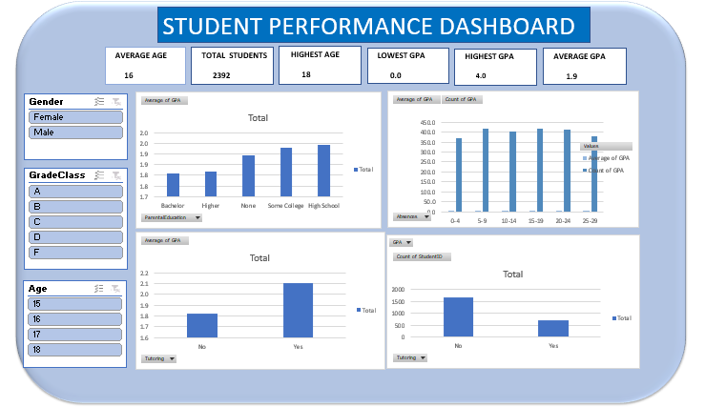
This Dashboard clearly illustrate trends and differences across variables, making the insights easier to interpret.

8. Recommendations

Actionable Strategies
- Implement early warning systems for students approaching 10–15 absences
- Expand tutoring programs, especially for students with GPA below 2.0
- Monitor attendance closely and enforce stricter policies
- Provide academic counseling for at-risk students
- Encourage consistent study habits through structured study programs

Expected Impact
- Improved student GPA across all categories
- Reduction in the number of low-performing students
- More effective academic support systems

9. Limitations
- The dataset is observational; causation cannot be confirmed
- External factors such as family income and school environment were not included
- The dataset may not fully represent all student populations

10. Conclusion
The analysis reveals that absenteeism is the most significant factor negatively affecting academic performance, while tutoring and study time contribute positively to GPA improvement. Parental education level shows minimal direct impact.
Addressing absenteeism and expanding academic support systems are critical strategies for improving student outcomes. Future studies should incorporate additional socio-economic variables to provide deeper insights.

